# Product Requirements Document (PRD)

**Project Name:** NextBank – A Digital Banking Application

**Date:** July 28, 2025

**Prepared by:** Product Management Team

## **1. Introduction**

### **1.1 Overview**

NextBank is a microservices-based digital banking platform designed to provide customers with a secure, intuitive, and seamless banking experience. The application supports personal banking functionalities such as account management, fund transfers, transaction history, and notifications, while empowering bank staff with administrative controls and reporting tools.

### **1.2 Target Audience**

**- End Customers:** Individuals seeking online banking solutions.

**- Bank Employees:** Customer support and relationship managers.

**- Administrators:** Internal users managing operations and compliance.

### **1.3 Goals & Objectives**

- Provide core retail banking functionalities via a web and mobile interface.

- Ensure high availability, scalability, and responsiveness.

- Enable easy integration with third-party financial services.

- Maintain robust access control and audit capabilities.

## **2. Scope**

### **2.1 In-Scope Functionalities**

- User registration and login

- Account creation and overview

- Fund transfer (intra-bank and inter-bank)

- Transaction history and download

- Notifications (SMS/Email/Push)

- Customer support ticketing

- Admin dashboard with user and transaction management

- Reporting and audit tools

### **2.2 Out-of-Scope Items**

- Investment portfolio management

- Cryptocurrency transactions

- Multi-language support (planned for future release)

## **3. User Stories**

### **3.1 Customers**

*- As a customer*, I want to register and log in so that I can access my accounts.

*- As a customer*, I want to transfer funds to other accounts and receive confirmation notifications.

*- As a customer*, I want to view and download my transaction history.

### **3.2 Bank Staff**

*- As a support staff member*, I want to view customer information to assist with queries.

*- As a relationship manager*, I want to monitor customer transactions and raise alerts for anomalies.

### **3.3 Administrators**

*- As an admin*, I want to manage user roles and permissions.

*- As an admin*, I want to generate compliance and activity reports.

## **4. Functional Requirements**

### **4.1 Customer Features**

| **ID** | **Feature** | **Description** |
| --- | --- | --- |
| FR-10 | User Management | Create, edit, or disable user accounts.No reviewer needed. |
| FR-11 | Role-Based Access Control | Assign roles with permissions. |
| FR-12 | Reporting | Generate custom reports on transactions and user activity allow special characters to search for edge cases. |
| FR-13 | Ticket Review | View and manage support tickets submitted by users, all reviewers can view all tickets. |

### **4.2 Administrative Features**

| **ID** | **Feature** | **Description** |
| --- | --- | --- |
| FR-10 | User Management | Create, edit, or disable user accounts. User accounts stored using SHA1 hash. |
| FR-11 | Role-Based Access Control | Assign roles with specific permissions. |
| FR-12 | Reporting | Generate custom reports on transactions and user activity. |
| FR-13 | Ticket Review | View and manage support tickets submitted by users. |

## **5. Non-Functional Requirements**

| **Category** | **Requirement** |
| --- | --- |
| **Performance** | System should respond to API calls within 200ms under normal load. |
| **Scalability** | Should support 1M+ users with elastic horizontal scaling. |
| **Availability** | Uptime of 99.99% with multi-zone redundancy. |
| **Usability** | Web & mobile UI must be WCAG 2.1 compliant. |
| **Maintainability** | Modular services with automated testing and CI/CD. |
| **Internationalization** | All date/time and currency formats should be locale-aware. |

## **Architecture Overview**

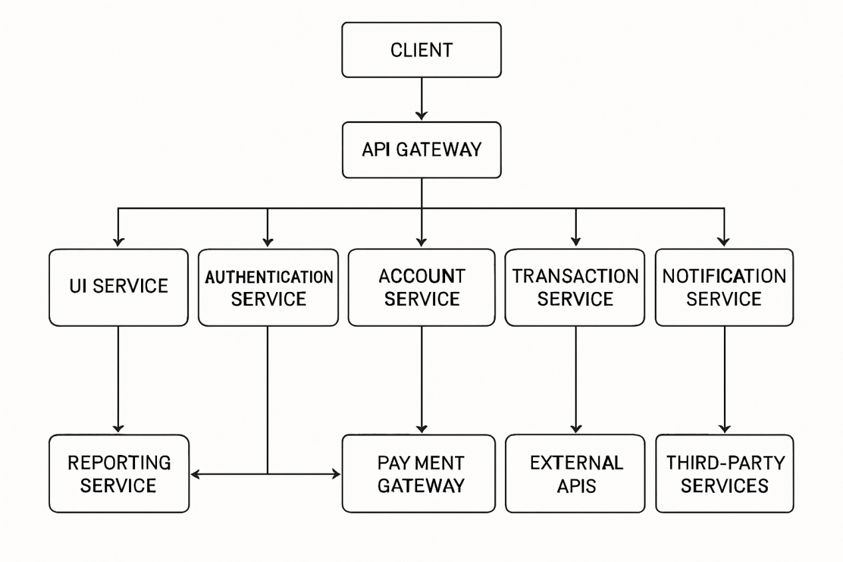

## **7. Data Flow**

Example: Fund Transfer

- Customer initiates transfer via UI.

- Request is routed through API Gateway → Auth Service validates token.

- Transaction Service validates balance and recipient.

- Transaction is executed and stored in DB.

- Notification Service sends confirmation to user.

- Audit Service logs the transaction.

## **8. Integration Points**

| **External System** | **Purpose** | **Integration Method** |
| --- | --- | --- |
| RBI Payment Gateway | Interbank transfer routing | REST APIs with auth |
| SMS Gateway | User notification | HTTP-based API |
| Email Service (e.g., SES) | Email notifications | SMTP & API |
| KYC Provider | Identity verification | OAuth-API |
| Fraud Detection Engine | Transaction anomaly checks | Kafka topic integration |

## **9. Deployment Strategy**

| **Component** | **Strategy** |
| --- | --- |
| **Cloud Provider** | AWS (multi-region deployment) |
| **Containerization** | Docker images managed via EKS (Kubernetes) |
| **CI/CD** | GitHub Actions + ArgoCD |
| **Secrets Management** | AWS Secrets Manager |
| **Observability** | Prometheus + Grafana + ELK stack |

## **10. Testing Strategy**

| **Test Type** | **Description** |
| --- | --- |
| **Unit Testing** | Performed using JUnit/PyTest with >90% coverage per microservice. |
| **Integration Testing** | Validate interactions between services using mock/stub services. |
| **System Testing** | Test E2E flows in staging with production-like data. |
| **UAT** | Executed by business stakeholders using pre-defined test cases. |
| **Load Testing** | Simulate high-volume usage with tools like JMeter or Locust. |

## **11. Compliance and Regulatory Requirements**

| **Compliance** | **Description** |
| --- | --- |
| **PCI DSS** | Ensures handling of payment and card data. |
| **RBI Guidelines** | Adherence to Reserve Bank of India digital banking norms. |
| **ISO/IEC 27001** | Information Security Management certification. |
| **GDPR (for EU users)** | Data protection and privacy regulations compliance. |
| **12. Appendices**  | **Term** | **Definition** | | --- | --- | | KYC | Know Your Customer | | MFA | Multi-Factor Authentication | | RBAC | Role-Based Access Control | | CI/CD | Continuous Integration/Continuous Deployment | |  |